**Project development phase**

**Sprint 4**

**Simulation on wokwi platform**

|  |  |
| --- | --- |
| Date | 12 november 2022 |
| Team ID | PNT2022TMID32046 |
| Project Name | Project – Smart Farmer-IoT Enabled smart Farming Application |

**Connecting Sensors with wokwi using C++**

#include <WiFi.h>//library for wifi

#include <PubSubClient.h>//library for MQtt

#include "DHT.h"// Library for dht11

#define DHTPIN 15     // what pin we're connected to

#define DHTTYPE DHT22   // define type of sensor DHT 11

#define LED 2

DHT dht (DHTPIN, DHTTYPE);// creating the instance by passing pin and typr of dht connected

void callback(char* subscribetopic, byte* payload, unsigned int payloadLength);

//-------credentials of IBM Accounts------

#define ORG "i3869j"//IBM ORGANITION ID

#define DEVICE_TYPE "abcd"//Device type mentioned in ibm watson IOT Platform

#define DEVICE_ID "1234"//Device ID mentioned in ibm watson IOT Platform

#define TOKEN "12345678"     //Token

String data3;

float h, t;

//-------- Customise the above values --------

char server[] = ORG ".messaging.internetofthings.ibmcloud.com";// Server Name

char publishTopic[] = "iot-2/evt/Data/fmt/json";// topic name and type of event perform and format in which data to be send

char subscribetopic[] = "iot-2/cmd/command/fmt/String";// cmd  REPRESENT command type AND COMMAND IS TEST OF FORMAT STRING

char authMethod[] = "use-token-auth";// authentication method

char token[] = TOKEN;

char clientId[] = "d:" ORG ":" DEVICE_TYPE ":" DEVICE_ID;//client id

//-----------------------------------------

WiFiClient wifiClient; // creating the instance for wificlient

PubSubClient client(server, 1883, callback ,wifiClient); //calling the predefined client id by passing parameter like server id,portand wificredential

void setup()// configureing the ESP32

{

**Serial**.begin(115200);

  dht.begin();

  pinMode(LED,OUTPUT);

  delay(10);

**Serial**.println();

  wificonnect();

  mqttconnect();

}

void loop()// Recursive Function

{

  h = dht.readHumidity();

  t = dht.readTemperature();

**Serial**.print("temp:");

**Serial**.println(t);

**Serial**.print("Humid:");

**Serial**.println(h);

  PublishData(t, h);

  delay(1000);

  if (!client.loop()) {

    mqttconnect();

  }

}

/*.....................................retrieving to Cloud...............................*/

void PublishData(float temp, float humid) {

  mqttconnect();//function call for connecting to ibm

  /*

     creating the String in in form JSon to update the data to ibm cloud

  */

  String payload = "{\"temp\":";

  payload += temp;

  payload += "," "\"Humid\":";

  payload += humid;

  payload += "}";

**Serial**.print("Sending payload: ");

**Serial**.println(payload);

  if (client.publish(publishTopic, (char*) payload.c_str())) {

**Serial**.println("Publish ok");// if it sucessfully upload data on the cloud then it will print publish ok in Serial monitor or else it will print publish failed

  } else {

**Serial**.println("Publish failed");

  }

}

void mqttconnect() {

  if (!client.connected()) {

**Serial**.print("Reconnecting client to ");

**Serial**.println(server);

    while (!!!client.connect(clientId, authMethod, token)) {

**Serial**.print(".");

      delay(500);

    }

     initManagedDevice();

**Serial**.println();

  }

}

void wificonnect() //function defination for wificonnect

{

**Serial**.println();

**Serial**.print("Connecting to ");

  WiFi.begin("Wokwi-GUEST", "", 6);//passing the wifi credentials to establish the connection

  while (WiFi.status() != WL_CONNECTED) {

    delay(500);

**Serial**.print(".");

  }

**Serial**.println("");

**Serial**.println("WiFi connected");

**Serial**.println("IP address: ");

**Serial**.println(WiFi.localIP());

}

void initManagedDevice() {

  if (client.subscribe(subscribetopic)) {

**Serial**.println((subscribetopic));

**Serial**.println("subscribe to cmd OK");

  } else {

**Serial**.println("subscribe to cmd FAILED");

  }

}

void callback(char* subscribetopic, byte* payload, unsigned int payloadLength)

{

**Serial**.print("callback invoked for topic: ");

**Serial**.println(subscribetopic);

  for (int i = 0; i < payloadLength; i++) {

    //Serial.print((char)payload[i]);

    data3 += (char)payload[i];

  }

**Serial**.println("data: "+ data3);

  if(data3=="lighton")

  {

**Serial**.println(data3);

digitalWrite(LED,HIGH);

  }

  else

  {

**Serial**.println(data3);

digitalWrite(LED,LOW);

  }

data3="";

}

**Program for resistor in Wokwi**

{

  "version": 1,

  "author": "Anonymous maker",

  "editor": "wokwi",

  "parts": [

    { "type": "wokwi-esp32-devkit-v1", "id": "esp", "top": 4.8, "left": -127.69, "attrs": {} },

    { "type": "wokwi-dht22", "id": "dht1", "top": -76.72, "left": 137.76, "attrs": {} },

    {

      "type": "wokwi-led",

      "id": "led1",

      "top": -16.04,

      "left": 21.83,

      "attrs": { "color": "red" }

    },

    {

      "type": "wokwi-resistor",

      "id": "r1",

      "top": 41.63,

      "left": 48.17,

      "attrs": { "value": "100" }

    }

  ],

  "connections": [

    [ "esp:TX0", "$serialMonitor:RX", "", [] ],

    [ "esp:RX0", "$serialMonitor:TX", "", [] ],

    [ "dht1:VCC", "esp:3V3", "red", [ "v0" ] ],

    [ "dht1:GND", "esp:GND.1", "black", [ "v0" ] ],

    [ "led1:A", "r1:1", "green", [ "v0" ] ],

    [ "led1:C", "esp:GND.1", "black", [ "v0" ] ],

    [ "dht1:SDA", "esp:D15", "green", [ "v101.76", "h-2.06" ] ],

    [ "r1:2", "esp:D2", "green", [ "v80.85", "h-3.49" ] ]

  ]

}

**Output**

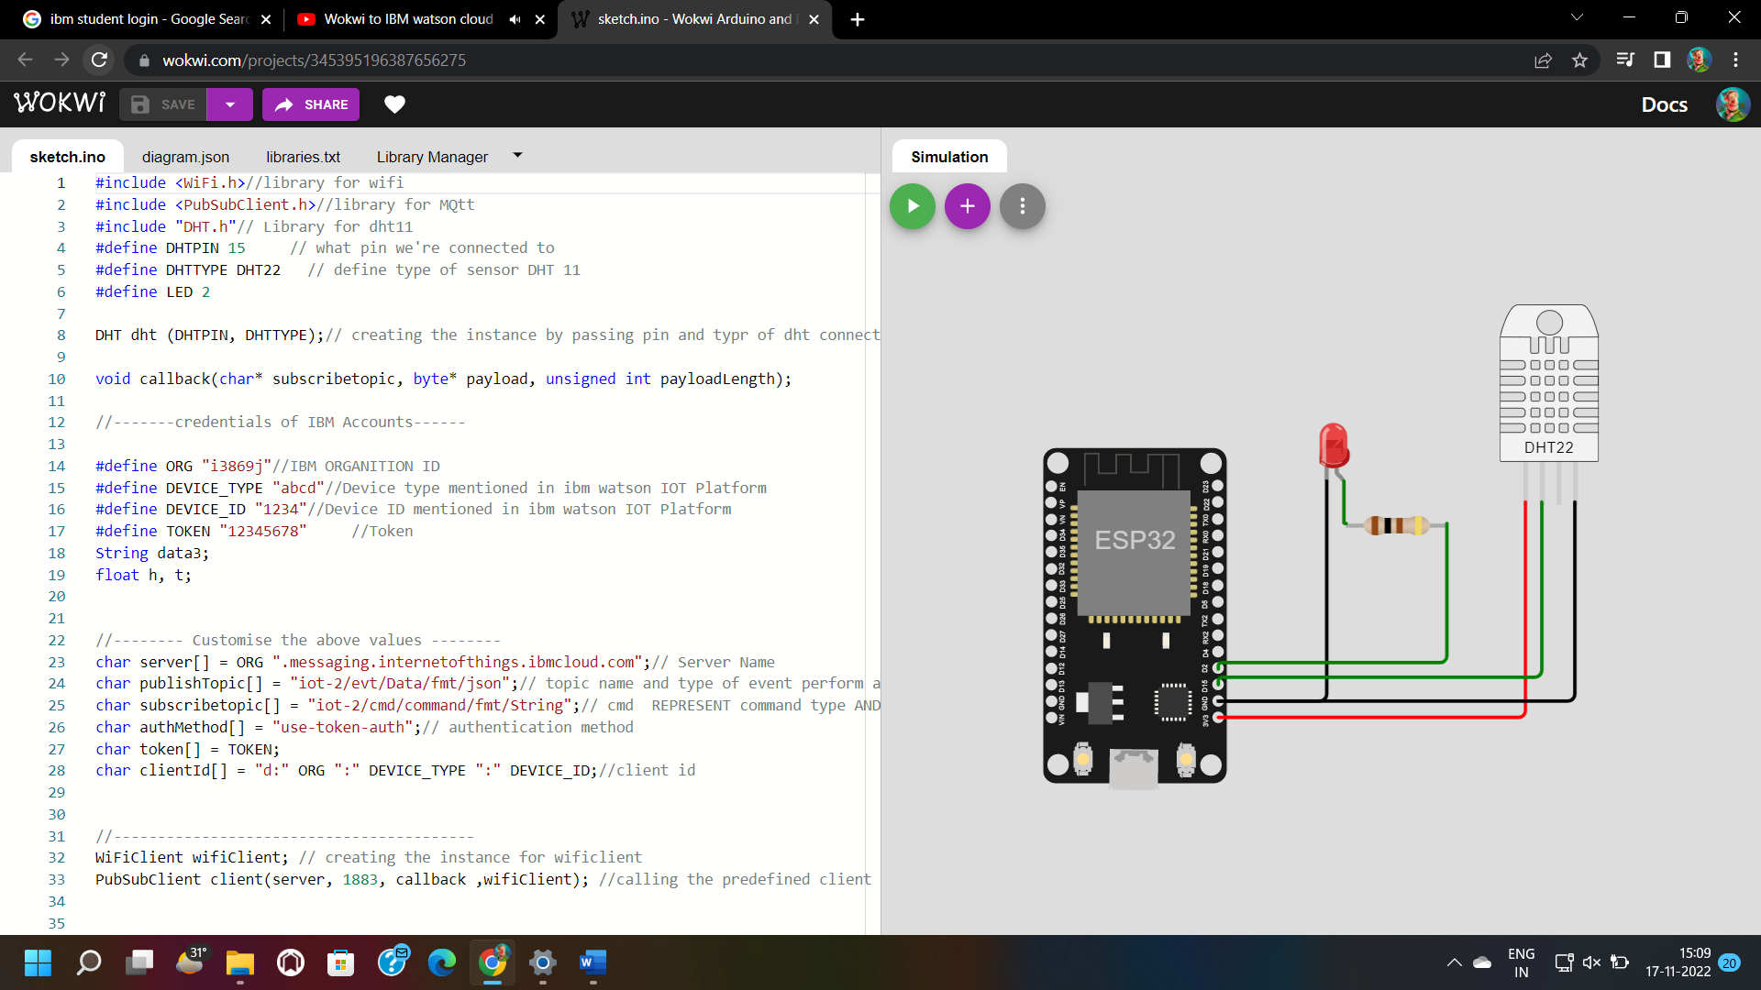

Output link :

https://youtube.com/shorts/2nmJcyUN2yQ?feature=share